Workforce Solutions Cameron Press Release

FOR IMMEDIATE RELEASE

DATE: November 3, 2023

MEDIA CONTACT: Pat Hobbs

PHONE: 956-548-6700

Workforce Solutions Cameron Selects New Executive Director

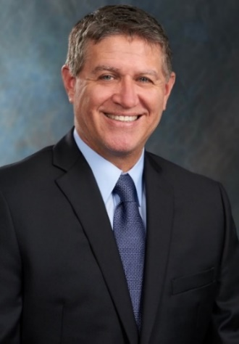
Brownsville – The Board of Director for Workforce Solutions Cameron named Rafael Vela as the new Executive Director on September 28, 2023. “As I plan to ‘exit stage left’ sometime in the near future, it is with many Thanks! to the Board of Directors that they allow me the opportunity to assist Mr. Vela in ‘learning the ropes’ of our workforce development system, imparting a little knowledge and experience along the way, and helping to make our leadership transition as smooth as possible. It is with full confidence in Mr. Vela’s abilities and dedication that I accept this challenge, as my passion for a vibrant workforce system is exceeded only by my gratitude to the many friends and partners who have made my tenure here such a pleasure!” said Pat Hobbs, the Chief Executive Officer of Workforce Solutions Cameron.

Mr. Vela brings a wealth of knowledge and experience into the public workforce system as a previous member of the workforce board, and appreciation for public service that perfectly aligns with the Board’s vision for the future. His experience and ability to unite cross-sectional partners will elevate workforce development to the next level of performance.

Mr. Vela has a passion for and deep connection to Cameron County. As a graduate of St. Edward’s University, he is looking forward to utilizing his experience and leadership to support innovative ways to expand opportunities for upward mobility for residents that will drive economic prosperity for the region. He intends to collaboratively work with workforce partners to develop a pipeline of skilled workers to address the needs in emerging and expanding industry sectors. The goal is to identify innovative solutions to address workforce issues that will strengthen the competitiveness of our local economy.
Workforce Solutions Cameron is among one of 28 local workforce boards located throughout the state of Texas. The primary goal of workforce boards is to meet the needs of employers and job seekers through locally designed, market-driven workforce development initiatives and services.
#

